F-04 -

Functionality

SAP System offers the following methods to clear accounts with open item management:
- Posting with clearing
Using the posting with clearing function, you enter document line items and then select the open items to be cleared. Once you have fulfilled all the prerequisites for clearing, the system clears the open items. The system generates one or more offsetting postings for the open items to be cleared
- Account clearing
In this clearing procedure, you select open items that balance to zero from an account. The system then marks these items as cleared. It enters a clearing document number and the clearing date in the document items. The clearing date can be the current date or a date that you enter manually. The clearing document number is the number of the most recent document involved in the clearing transaction.
- Automatic Clearing
You can use the Automatic clearing program to clear open items from customer, vendor, and G/L accounts. This program uses predefined criteria to group together open items per account. If the balance of the group of open items equals zero in local, foreign, and where applicable, the parallel currency, the items are marked as cleared.
Scenario
In this scenario we performed post with clearing using transaction code F-04 (Manual clearing) with Partial clearing function.
You can perform the same clearing for GL Account without posting using F-03.

Requirements
None

Menu Path | Accounting → Financial Accounting → General Ledger → Document Entry → F-04 - Post with Clearing
Transaction Code | F-04

1. Double click on F-04 - Post with Clearing

Post with Clearing: Header Data

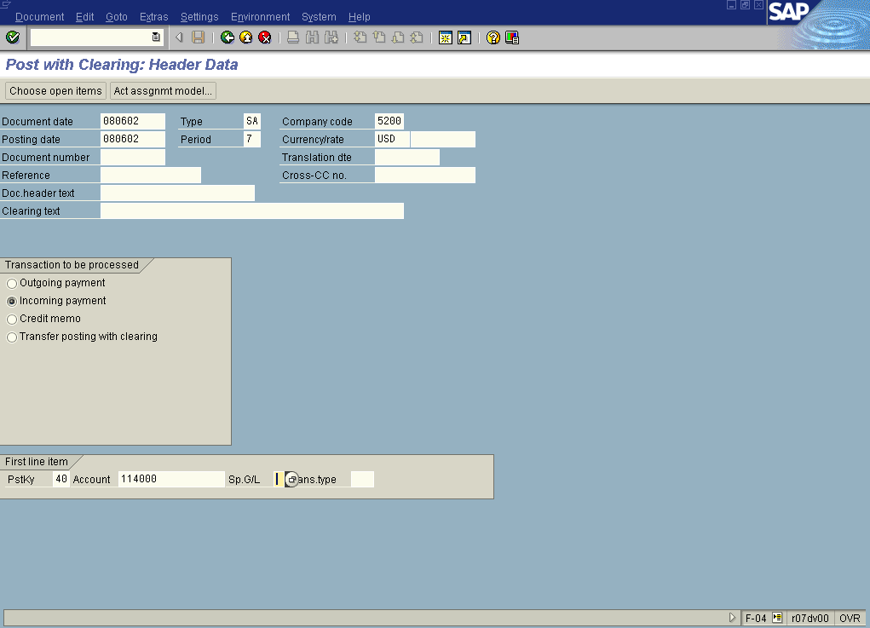

2. Update the following fields:

Field Name | Field Description | Values
Document date |  | Example: 08.06.2002
Company code | Enter here required company code number | Example: 5200
Period | Number identifying a fiscal month | Example: 06
Currency/rate | Code identifying the currency used in the transaction | Example: USD
PstKy | Description of the PstKy. | Example: 40
Account | Code identifying the General Ledger, Vendor, or Customer account | Example: 114000

3. Click Enter Button to confirm your entries.

Post with Clearing: Add G/L account item

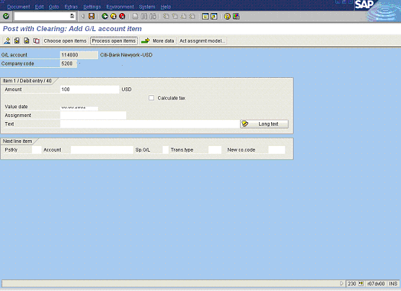

4. Update the following fields:

Field Name | Field Description | Values
Amount | Amount of the line item | Example: 100

5. Click Process open items Button .

Post with Clearing: Select open items

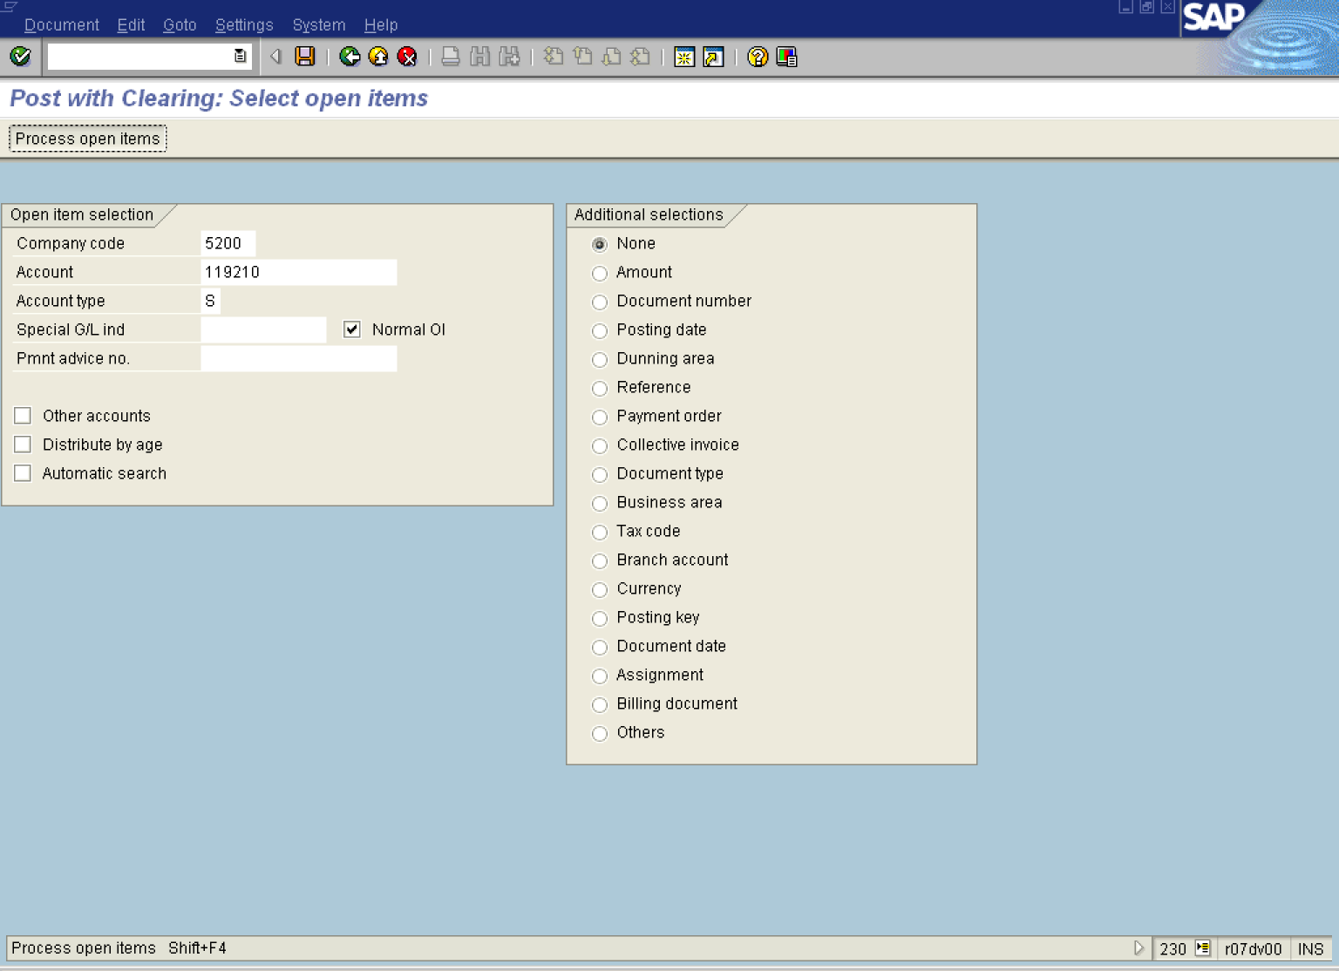

6. Update the following fields:

Field Name | Field Description | Values
Account | Code identifying the General Ledger, Vendor, or Customer account | Example: 119210

7. Click Process open items Button .

Post with Clearing: Process open items

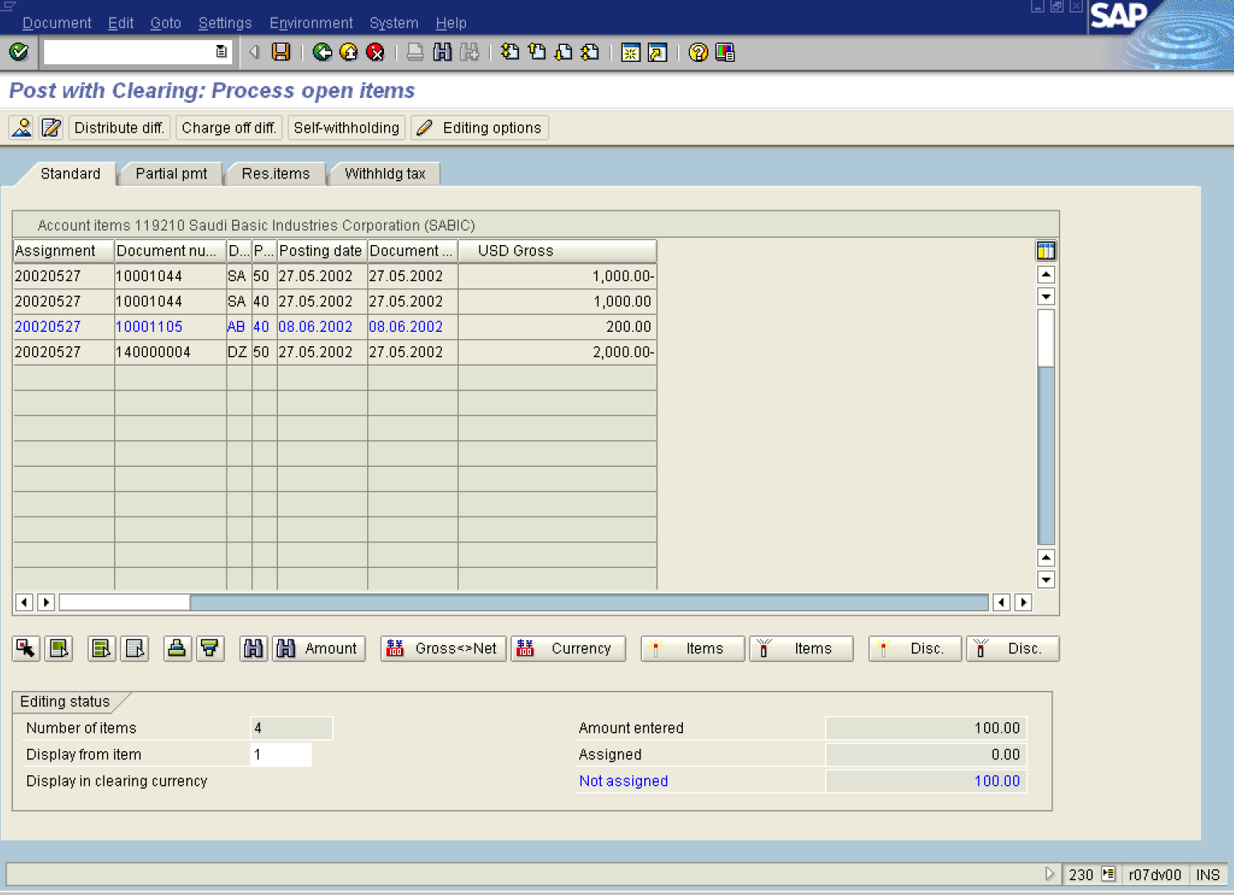

Note: All open items are selected. You need to deselect them first:

8. Click Select all F7 Button .

9. Click Items Button . Deactivate Items

10. Click 20020527 Button 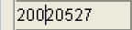. Line Item To be Cleared

11. Click Select Button .

12. Click <tab button> Partial pmt .

Post with Clearing: Enter partial payments

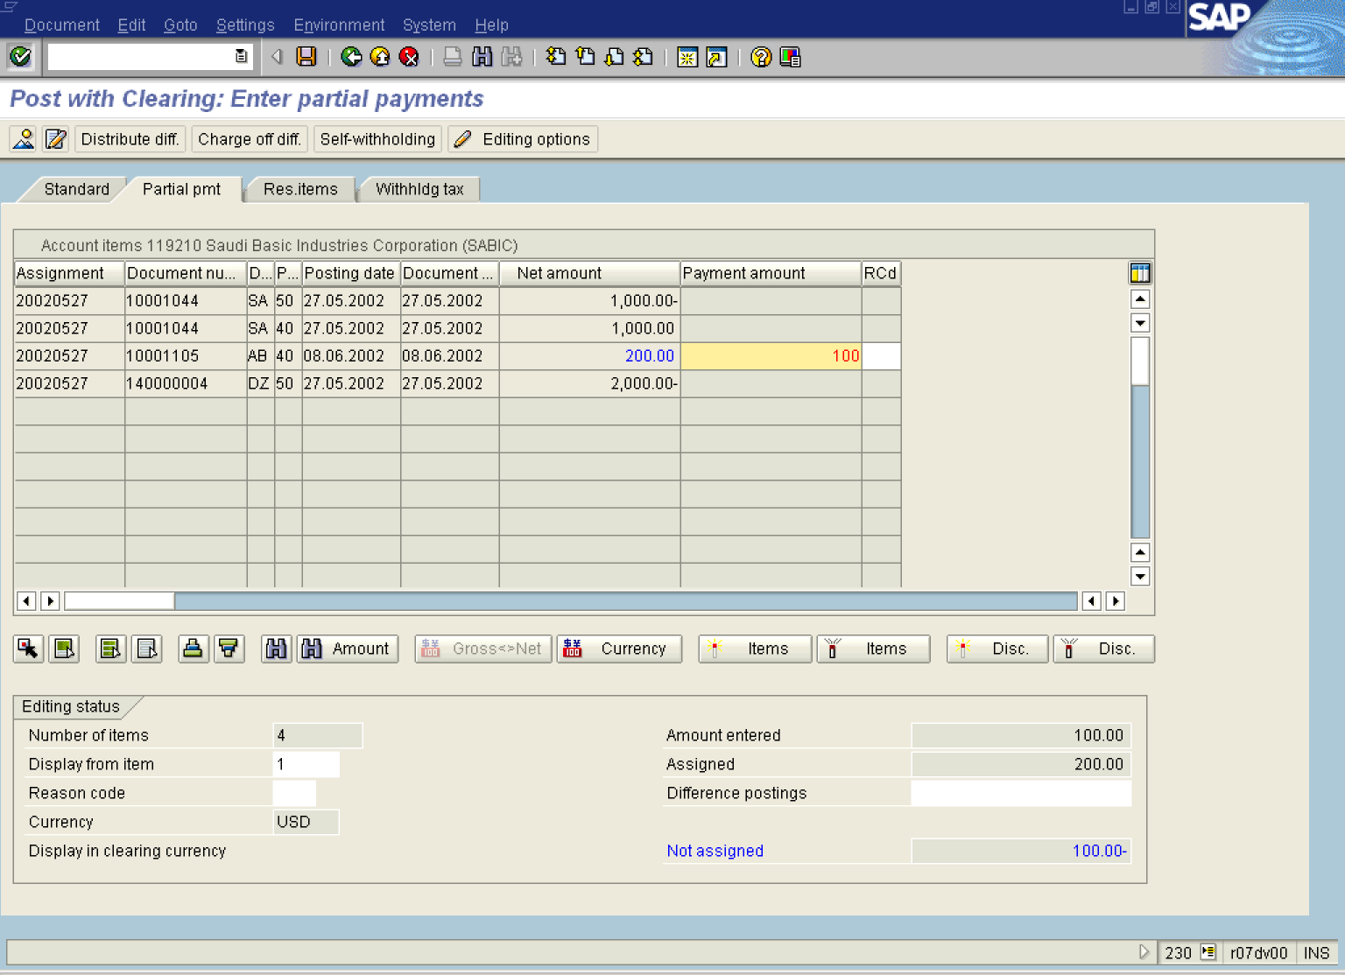

Note: With manual clearing only there are 3 way of clearing an open item (full , partial , residual) .
A residual item results when a payment is made for less than the actual amount outstanding. You clear the original open item, and the system posts a new open item. This new open item is for the same amount as the original open item minus the amount paid
A partial payment is a payment that is posted to an account without any open items being cleared. You assign this partial payment to an open item. When you post the partial payment, the system marks the document number of the original open item in the line item for the partial payment. The original open item and the partial payment remain open.
For automatic clearing there are 2 transaction codes :
· F.13 - Without Specification of Clearing Currency
· F13E - With Clearing Currency Specified.

13. Update the following fields:

Field Name | Field Description | Values
Payment amount | Description of the Payment amount. | Enter value in Column Payment amount.  Example: 100

14. Click Enter Button to confirm your entries.

15. Select DocumentSimulate.

Post with Clearing: Display Overview

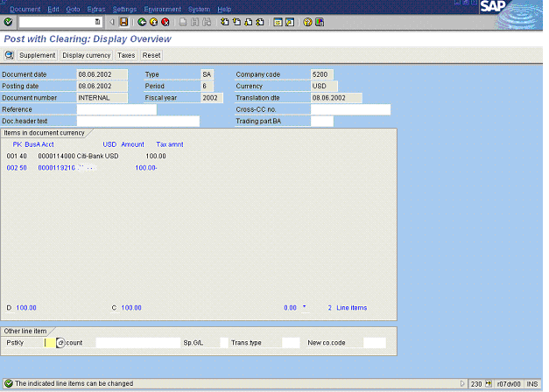

16. The line 002 is highlighted in blue – some additional data must be entered. Double click on this line and enter the required information.

17. Click Save Button. to post your document.

18. The message bar displays “Document 10001101 was posted in company code 5200”

